ARTICLE

**Phenotypical**

Sandy Kroh 2,3, Anna Pascual-Reguant, Artür Manukyan, Ralf Uecker 2,3, Robert Günther, Lars Philipsen, Ralf Köhler, Peggy, Raluca A. Niesner, Anja E. Hauser 2,3

The

**Subject Terms**

2 Charite – Universitätsmedizin Berlin, Department of Rheumatology and Clinical Immunology, 10117 Berlin, Germany. 3 Immune Dynamics, Deutsches Rheuma-Forschungszentrum (DRFZ), a Leibniz Institute, Charitéplatz 1, 10117 Berlin, Germany.

**INTRODUCTION**

**T**he

ILCs and ILC subtypes

Lung gut axis

Spatial analysis

**Combining cyclic IF with a systemic inflammation model to study ILCs niches in murine lung and SI tissues**

* Why IL-33 model
* Why early time points
* As innate immune cells, ILCs are potent sensors of cytokines and changes in their microenvironment.

12- to 14-week-old females of GATA3eGFP reporter mice were i.p.-injected with 300 ng IL-33 on up to three consecutive days, organs were isolated 24 hours after the last dose of IL-33 and prepared for MELC (Fig. 1A).

* How many markers were established in lung tissue
* Focus of marker panel

Ein Bild, das Text, Screenshot, Diagramm enthält.

**Figure 1: (A)** Schematic of the experimental set-up of the IL-33 systemic inflammation model and the MELC experiment. In short, 12-14-week-old GATA3eGFP reporter mice were i.p. injected with 300 ng IL-33 on up to 3 consecutive days. 24 h after the last dose, organs were harvested and processed for cyclic IF (MELC). In each MELC experiment, three regions of interest (fields of view = FOV) were acquired, each measuring 665 x 665 µm. **(B)** Overview of an established 40-marker panel in an exemplary tissue region of murine lung. Each image shows the same tissue region stained for diverse immune markers (magenta) and structural markers (darkcyan), as well as nuclei stains (yellow). Scale bar represents 200 µm.

**Major immune and non-immune cells are annotated from cyclic IF data using the Seurat workflow**

Analysis was performed for the lung data and SI data separately. Dimensionality reduction and cluster analysis of the lung data resulted in three clusters (Fig. 2A). The clusters were annotated based on the respective feature profile (Fig. 2). Thereby, immune cells showed high levels of the pan-leukocyte marker CD45, as well as different markers for T cells, B cells, Plasma cells, and myeloid cells, such as CD3, B220, Kappa, CD67, respectively. The cluster annotated as stromal cells was high in endothelial and fibroblast-associated markers EMCN, CD31, LYVE1, PDPN, Sca1, and PDGFRa, while the cluster annotated as epithelia was marked by a high level of EpCAM. For visual validation, the annotated cell types, namely immune cells (Darkcyan), stromal cells (Darkmagenta), and epithelia (Gold), of each FOV were depicted in x and y (Fig. 2 C) and compared to the respective MELC IF overlays of CD45 (Cyan), CD31 (Magenta), and EpCAM (Yellow) showing correlating distribution patterns (Fig. 2D).

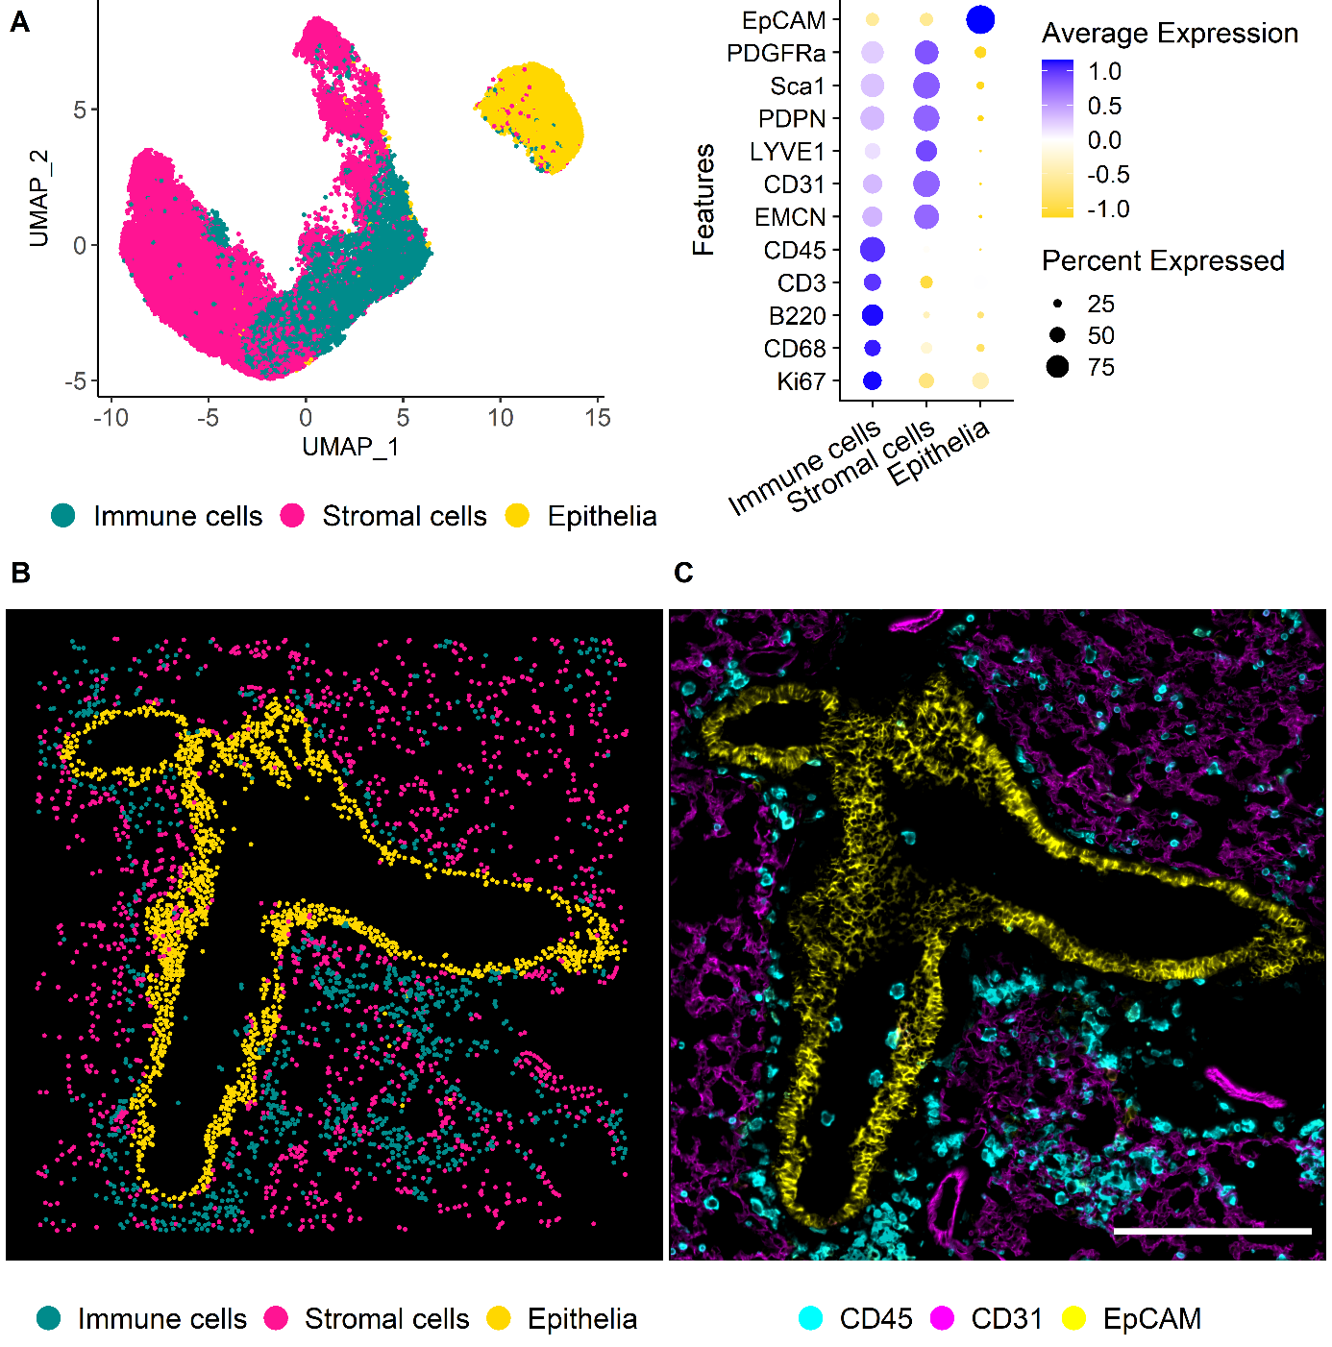

**Figure 2: (A)** UMAP representation of the first level of annotation (AL1) in murine lung tissue showing the three clusters annotated as Immune cells, stromal cells, and epithelia based on the feature profiles shown in the dot plot beside. **(B)** Annotated clusters of AL1 mapped in X and Y. Annotations are colored by cell type with immune cells (Cyan), vessels (Magenta), and epithelia (Yellow). **(C)** IF overlay of CD45 (Cyan), CD31 (Magenta), and EpCAM (Yellow) of the same FOV shown in B. Scale bar: 200 µm.

**Three ILC subtypes are resolved and ILC2s represent the predominant subtype in murine lung tissue**

* Increase granularity for immune cells
* Identify immune subsets and ILCs
* Identify ILC subtypes
* Also reclustering of epithelial and vessel cluster

Ein Bild, das Text, Screenshot, Diagramm, Design enthält.

**Figure 3: (A)** Dot plot showing the marker profiles of the annotated immune cell types in murine lung including ILCs. **(B)** Ridge plots of ILC-related markers showing the levels for the identified ILC subsets in murine lung NK cells/ILCs, ILC2s, and ILC3s. **(C)** Visual validation NK cells/ILC1s. Cells are depicted on IF overlay of TBET (Cyan), EOMES (Magenta), CD3 (Yellow). **(D)** Visual validation of ILC2s. Cells are overlayed with GATA3eGFP (Cyan), CD45 (Magenta), and CD3 (Yellow). **(E)** Visual validation of identified ILC3s. Cells annotated as ILC3s are depicted on IF overlay showing RORgt (Cyan), CD90.2 (Magenta) and CD3 (Yellow). (D-E) Identified cells are depicted as white circles, each circle representing one cell. White boxes mark regions of interest that are zoomed in respectively on the right side. Scale bars represent 200 µm in overviews, and 20 µm in ROIs.

**Lung ILC2s are the predominant ILC subtype in murine lung and only increase at IL-33 day 3**

* ILC composition under healthy conditions
* Total cell count, total immune count, total ILC count
* Immune frequency, ILC frequency, ILC subtypes

**Spatial analysis reveals accumulation of ILC2s in peri-lymphatic niches shared with myeloid cells in lung**

The

**Lung NK cells/ILC1s and intestinal NK cells/ILC1s/ILC3s accumulate in peri-vascular tissue areas**

While

**ILC2s and a mixed cluster of NK cells/ILC1s/ILC3s are resolved in murine SI tissues**

We

**DISCUSSION:**

**MATERIAL AND METHODS**

**Human gingival tissue:**

Oral

**Tissue Preparation for MELC**

Fresh frozen tissue was cut 5 µm thick with a NX80 cryotome (ThermoFisher, Waltham, Massachusetts, USA) on 3-aminopropyltriethoxysilane (APES)-coated cover slides (24 × 60 mm; Menzel-Gläser, Braunschweig, Germany). Samples were fixed for 10 min at room temperature using a freshly opened EM grade PFA ampulla (methanol- and RNAse-free; Electron Microscopy Sciences, Hatfield, Philadelphia, USA) diluted to 2%. After washing three times with PBS, samples were permeabilized with 0.2% Triton X-100 in PBS for 10 min at room temperature. Subsequently, a blocking step with 10% goat serum and 1% BSA in PBS was performed for at least 20 min. Afterwards, a fluid chamber holding 100 μl of PBS was created using “press-to-seal” silicone sheets (Life technologies, Carlsbad, California, USA; 1.0 mm thickness) with a circular cut-out (10 mm diameter), which was attached to the coverslip, surrounding the sample.

For every MELC run, a bottle of fresh PBS with 1% BSA and 0.02% Triton X-100 was used. The sample was placed on the sample holder and fixed with adhesive tape followed by accurate positioning of the binning lens, the light path, as well as Köhler illumination of the microscope.

**MELC image Acquisition**

**MELC Antibody Panel**

**Image Pre-processing**

**Reporting summary**

**REFERENCES**

**ACKNOWLEDGEMENTS**

We would like to thank x for helpful discussions. This study was supported by a grant from the DFG to A.E.H and ECRT (Einstein Centrum für Regenerative Therapien) to A.A. The authors affiliated with Charité for the duration of this study acknowledge that Charité is a corporate member of Freie Universität Berlin and Humboldt-Universität zu Berlin.

**AUTHOR´s CONTRIBUTIONS**

A.A., S.K. and A.E.H. conceptualized the study. P.B. and M.K. provided samples. A.A., S.K, H.G. and R.U. performed experiments. A.A., S.K., A.E.H. analyzed the data and interpreted the results and wrote the manuscript. A.A., S.K., A.E.H., H.D. discussed the results and reviewed the manuscript.

**FUNDING**

DFG (Anja fragen, wir haben kein DFG Funding)

**COMPETING INTERESTS**

The authors declare no competing interests

**ADDITIONAL INFORMATION**

**Supplementary Information**

**Correspondence** and requests for materials should be addressed to A.E.H

**Peer review information**

**Reprints and permission information** is available at

**Publisher´s note**

**Open Access**

**Figure 1**

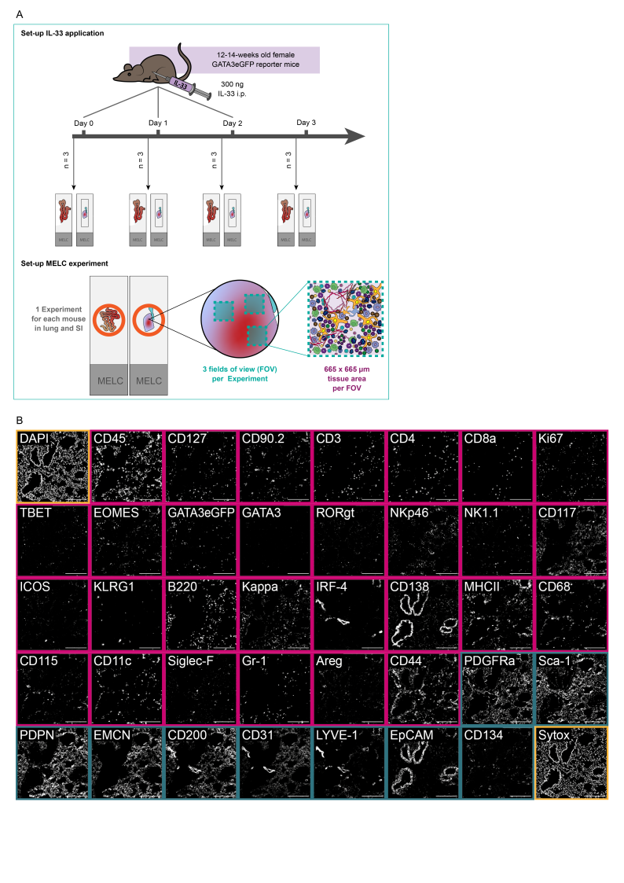

**(A)** Schematic of the experimental set-up of the IL-33 systemic inflammation model and the MELC experiment. In short, 12-14-week-old GATA3eGFP reporter mice were i.p. injected with 300 ng IL-33 on up to 3 consecutive days. 24 h after the last dose, organs were harvested and processed for cyclic IF (MELC). In each MELC experiment, three regions of interest (fields of view = FOV) were acquired, each measuring 665 x 665 µm. **(B)** Overview of an established 40-marker panel in an exemplary tissue region of murine lung. Each image shows the same tissue region stained for diverse immune markers (magenta) and structural markers (darkcyan), as well as nuclei stains (yellow). Scale bar represents 200 µm.

**Supplementary figure 1**

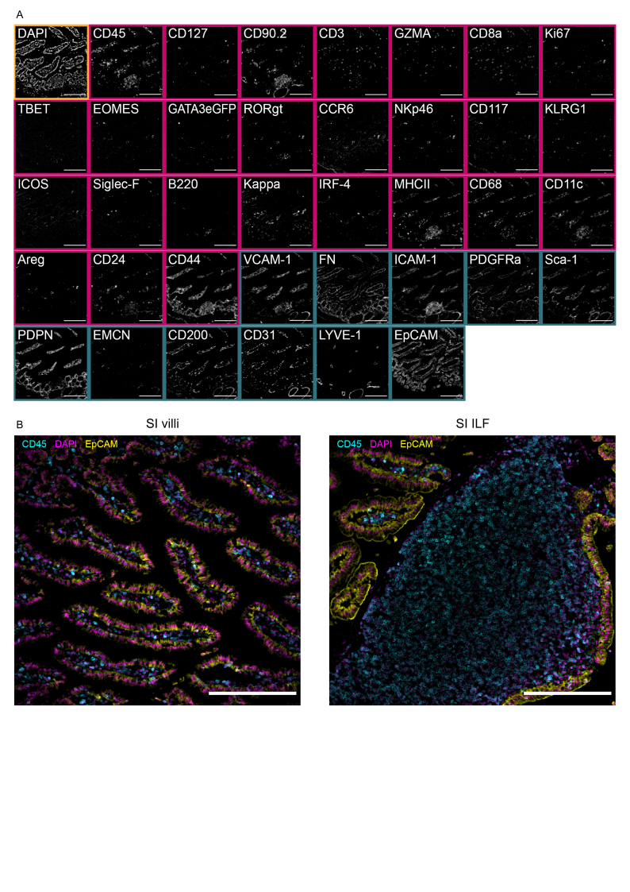

**(A)** Overview of an established 38-marker panel in an exemplary tissue region of murine small intestine. Each image shows the same tissue region stained for diverse immune markers (magenta) and structural markers (darkcyan), as well as the nuclei stain DAPI (yellow). **(B)** IF overlays of the pan-immune marker CD45 (Cyan), the nuclear stain DAPI (Magenta), and the epithelial marker EpCAM (Yellow) acquired by MELC in the small intestine. Small intestinal tissue regions were categorized into SI villi and SI ILF based on the predominant tissue structures visible in the acquired images. Scale bar represents 200 µm.

**Figure 2**

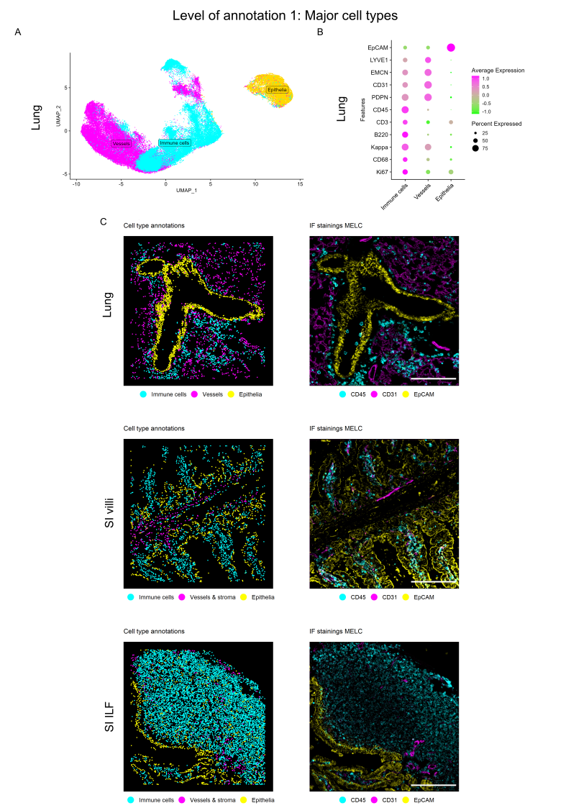

**(A)** UMAP representation of the first level of annotation (AL1) in murine lung tissue showing the three clusters annotated as Immune cells, vessels, and epithelia based on the feature profiles shown in the dot plot below. **(B)** Dot plot **(C)** Annotated clusters of AL1 mapped in X and Y next to the respective immunofluorescence (IF) overlay of correlating marker stainings for a representative field of view (FOV) of lung (upper panel), SI villi (middle panel), and SI ILF (lower panel). Annotations are colored by cell type with immune cells (Cyan), vessels (Magenta), and epithelia (Yellow), and correlate with CD45 (Cyan), CD31 (Magenta), and EpCAM (Yellow). Scale bar: 200 µm.